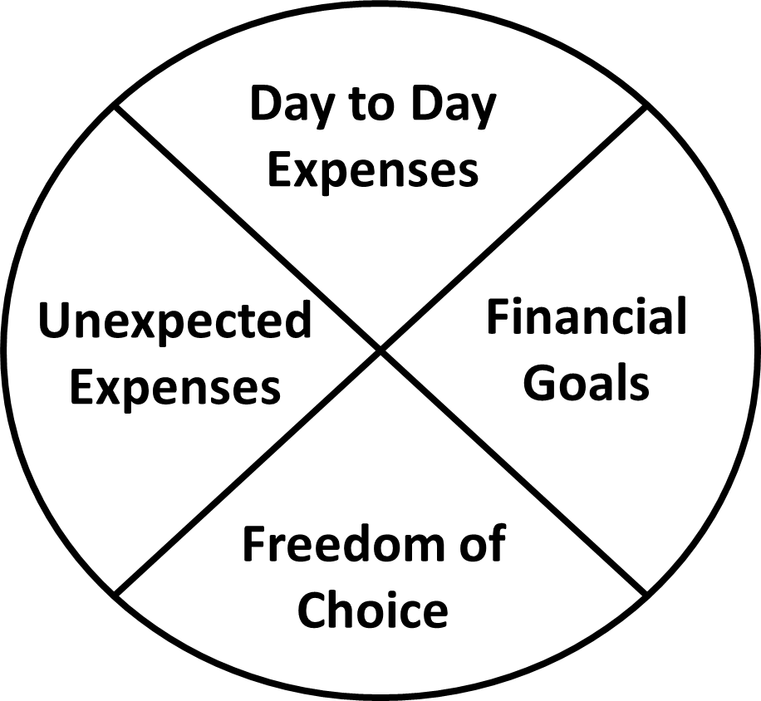

*I will do ________________________ by ____________________________.*

OPTIONAL OFFER:

If you would like to be held accountable for your action step, please feel free to send me an email. I will then email you on your deadline date to see if you’re happy with your progress.

Case Manager E-mail:

**ACTION:**

**ACTION:**

**ACTION:**

**ACTION:**

**Financial Planning Worksheet**

What’s one thing you can do in the next week for your own financial well-being?

Pick an area and write in your action step.